SAVE THE DATE SAVE THE DATE SAVE THE DATE SAVE THE DATE SAVE THE DATE SAVE THE DATE SAVE THE DATE SAVE
2nd Annual Pizza Pi Night:
A Family Math Game Night

Monday, March 14, 2016
Bayside High School
6 - 7:30pm
SAVE THE DATE SAVE THE DATE SAVE THE DATE SAVE THE DATE

SAVE THE DATE SAVE THE DATE SAVE THE DATE SAVE THE DATE

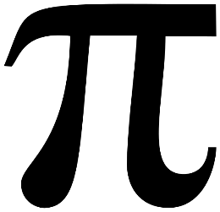

SAVE THE DATE SAVE THE DATE SAVE THE DATE SAVE THE DATE SAVE THE DATE SAVE THE DATE SAVE THE DATE SAVE

SAVE THE DATE SAVE THE DATE SAVE THE DATE SAVE THE DATE SAVE THE DATE SAVE THE DATE SAVE THE DATE SAVE
2nd Annual Pizza Pi Night:
A Family Math Game Night

Monday, March 14, 2016
Bayside High School
6 - 7:30pm
SAVE THE DATE SAVE THE DATE SAVE THE DATE SAVE THE DATE

SAVE THE DATE SAVE THE DATE SAVE THE DATE SAVE THE DATE

SAVE THE DATE SAVE THE DATE SAVE THE DATE SAVE THE DATE SAVE THE DATE SAVE THE DATE SAVE THE DATE SAVE

