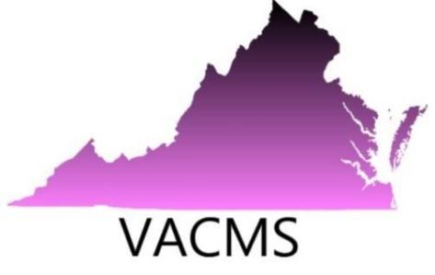
Virginia Council of Mathematics Specialists
2022 Annual Conference
October 28, 2022
University of Mary Washington Stafford Campus
121 University Boulevard
Fredericksburg, VA 22406

VACMS is excited to resume our annual conferences in a face-to-face format October 28, 2022. Our members appreciated the virtual opportunities for networking over the past two years but are looking forward to reuniting with colleagues and meeting new colleagues. Vendors have been essential partners in our past face-to-face conferences. We hope you will join us this year to bring information about available mathematics instruction and coaching resources.

The conference theme is Coaching for Advocacy---Advocacy for Coaching. We expect over 200 presenters, mathematics specialists/coaches, and teacher leaders. Skip Tyler, a mathematics education leader, will be our keynote speaker.

The conference program will include participating companies and their company logo. Vendors who wish to contribute items to be placed in participants’ bags or for prizes are welcome to send the items to Vickie Inge, vendor contact at 9818 Lees Mill Road, Warrenton, VA 20186.

If you have questions, please contact Vickie Inge at vickieinge@gmail.com.

Additional information about the conference will be available at the VACMS website, www.vacms.com .

VACMS October 28, 2022 Conference: Vendor Application

Please complete the following.

Company:
Vendor Name:
Vendor Cell Phone Number:
Vendor Email Address:
REQUEST FOR TABLE(s)
Please check the number of tables you are requesting for the conference. Vendors may use only tables provided by the University of Mary Washington. Since electrical outlets are located around the walls, an extension cord may be necessary in some cases.
□ One vendor table $150.00
□ Two vendor tables $200.00
Please email your completed application and company logo to:
Vickie Inge by August 24, 2018 at
vickieinge@gmail.com

Payment must be mailed to:
Vickie Inge
Attn: Virginia Council of Mathematics Specialists
9818 Lees Mill Rd.
Warrenton, VA 20186

______________________________________________________________________________
Please email your completed application and company logo to:
Please email your completed application and company logo to:
Vickie Inge by August 24, 2018 at
vickieinge@gmail.com

Payment must be mailed to:
Vickie Inge
Attn: Virginia Council of Mathematics Specialists
9818 Lees Mill Rd.
Warrenton, VA 20186

Vickie Inge, no later than October 1, 2022, at vickieinge@gmail.com

Mail payments to:

VACMS
Attn: Vickie Inge
9818 Lees Mill Rd.
Warrenton, VA 20186

- Vickie will email confirming receipt of your request.
- Vickie will email directions with specific logistical information no later than October 15.

Thank you for helping to support our members and our conference. VACMS looks forward to working with you!

